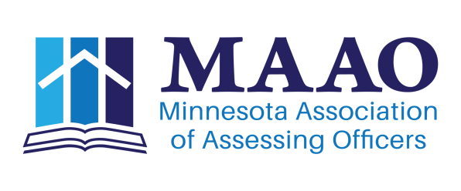
Information Systems Committee Report
February 23, 2017

- Number of Website updates
  - Regions that haven’t sent updates please do.
  - If you have sent updates and the web hasn’t been updated, please drop me a note.
- MAAO Inventory
  - 2017 Replacements
    - Jackie’s Surface Pro
    - Couple of External Hardrive’s (Reed & Matt)
    - Editorial laptop failure, replacement in process
      - If you are having laptop issues, drop me a note.
- Committee Chair Website Training Ongoing
  - Looking to set up additional training either one on one or group sessions.
  - One on one would be easier to schedule. Let me know if interested.
- Jobs Board Update
  - Contract finalized 1/4/2017
  - Official welcome packet received 2/9/2017
    - We are working through the setup process with MemberClicks and Your Membership
    - Need to work with Membership Committee to set up Social Media Channels to push content to.
    - Planning a Summer Seminar roll out.
  - Snafu’s
    - Only one identified so far, it is a result of member/non member postings.
    - YourMembership utilizes single sign on with Memberclicks profile.
      - That means if an MAAO member logins in and posts a job under their profile its considered a member posting.
      - If a Jurisdictions HR Member tries to post a job without a MAAO Member login, it would be considered a non member posting.
      - Solution would be to create Affiliate Memberships for HR Personnel or know that a MAAO Member needs to post the job.

2014 78 postings
2015 88 postings
2016 87 postings
2017 YTD 5 postings

Respectfully Submitted
Matt Gersemehl, Information Systems Chair

